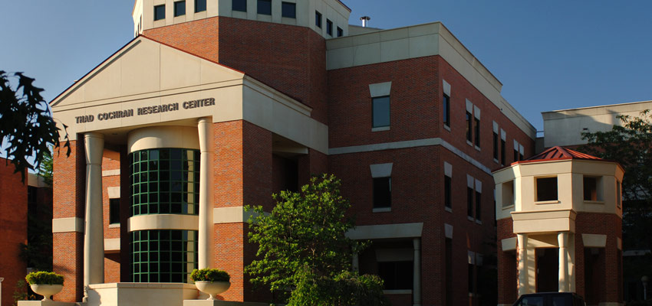
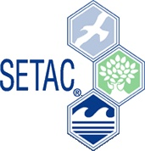

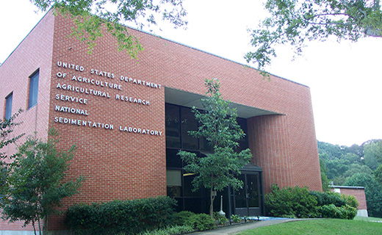

Oxford, MS – May 18-19, 2017

You are invited to attend the MidSouth SETAC Regional Chapter annual meeting to be held on the campus of The University of Mississippi and the USDA National Sedimentation Laboratory in Oxford, Mississippi. Oxford has been named by USA Today as one of the top six college towns in the nation and is also included in The Best 100 Small Towns in America. SETAC is a not-for-profit, worldwide professional organization that promotes the advancement and application of science related to contaminants and other environmental stressors, education in the environmental sciences, and the use of science in environmental policy and decision-making. SETAC’s mission is protecting, enhancing and managing sustainable environmental quality as well as ecosystem integrity. Join us at MidSouth SETAC in Oxford!

We are inviting abstracts and participation in all areas but especially in Natural Resources Management, Multidisciplinary Approaches to Solving Environmental Problems, Science and Education, Sustainability, and of course, Environmental Toxicology and Chemistry!
Abstracts for platform and poster presentations must be submitted by MAY 5, 2017.

The 2017 annual meeting will start Thursday afternoon, May 18, at 1:30 PM on the USDA National Sedimentation Laboratory campus with a short-course entitled “The Ins and Outs of Scientific Publishing and Peer Review” instructed by Drs: Erin Bennett, Piero Gardinali, Kristie Willett, and Matt Moore. This short course will provide the participants with step by step considerations as they plan and prepare manuscripts for journal submission. Additionally, it will cover best practices for peer reviewing scientific papers. Short course participants will have the opportunity to query the insight of four editors of environmental toxicology and chemistry relevant journals and will be invited to bring drafts of papers in preparation to workshop during break out groups of the course. This workshop is designed to help individuals, both novice and experienced reviewers, to understand the process and how to provide a useful peer-review while making the peer-review process as efficient and productive as possible. This workshop will consist of two components, the first part will focus on the publication and peer review process (a step by step tutorial) and the second part will be an open discussion to ask questions about the process and to discuss personal experiences. In addition, at least one case study will be presented for further discussion. Immediately following the short-course, attendees will tour the National Sedimentation Laboratory. A reception at The Graduate with spirits and refreshments will allow the attendees to unwind and network.

On Friday, May 19, we will meet on the University of Mississippi campus with our first keynote speaker Dr. Piero Gardinali. Dr. Gardinali is a professor at Florida International University in the department of Chemistry and Biochemistry. Dr. Gardinali’s research interests are analytical chemistry, source fate and transport of organic pollutants in marine ecosystems, and biological markers of chemical exposure. His talk will be followed by oral and poster presentations on topics related to different aspects of environmental toxicology and chemistry in the MidSouth region. We will then take a break to enjoy a catered lunch. Following lunch, Dr. Scott Rush will be presenting the second keynote lecture. Dr. Rush is a professor at Mississippi State University in the department of Wildlife, Fisheries, and Aquaculture. Dr. Rush’s research interests are ecology and conservation of tidal systems, community ecology in large lakes, fire ecology, and urban wildlife ecology. A poster session will follow. We will conclude with a short business meeting and awards ceremony.
Registration for the meeting will be $40/regular and $20/student. On-site registration must be cash or check. Registration includes the short course, Thursday evening reception, and Friday’s breakfast and lunch.

Oxford has many fine hotels in a range that will match your budget. We suggest the following lodging options:
1. The Inn at Ole Miss (15 rooms are blocked for guests)
$109.00/standard accommodations

Method of Reservation – call 1( 888) 486-7666 and reference SETAC Meeting Group for the block room and rate.
Reservation may also be made online at www.theinnatolemiss.com. Reference the group code 3319.

Must make your reservation on or before May 1, 2017!

The following options are available but not specifically blocked for SETAC event:

2. Courtyard Marriott (walking distance to campus)
305 Jackson Ave. E
Oxford, MS 38655
(662) 638-6014
http://www.marriott.com/hotels/travel/uoxcy-courtyard-oxford/

3. The Graduate Oxford (off the historical campus square)
400 North Lamar Blvd
Oxford, MS 38655
(662) 234-3031
www.graduateoxford.com

Registration information may be found on the Mid-South SETAC website (www.setac.org/midsouth) or by calling (662) 915-7101 or (662) 915-6691.
CALL FOR ABSTRACTS

The organizing committee of the 2017 MidSouth SETAC meeting welcomes submission of abstracts for platform and poster presentations. All abstracts must be formatted according to the example abstract below and submitted as a MS Word email attachment to Dr. Kristie Willett at kwillett@olemiss.edu by May 5th.

Abstracts should not exceed the length of one page including authors, contact and presentation information and should follow the format of the attached sample abstract below. Abstracts over one page length will be edited without author's review. Poster presentation boards will be up to 48 inches (wide) by 48 inches (tall) and attached using pins or tacks. Abstract submissions must be received on or before May 5, 2017.

Sample Abstract Submission
Author to Contact:
Jessica Coleman
Environmental Laboratory
US Army Engineer Research and Development Center
3909 Halls Ferry Road, Bldg 6011
Vicksburg, MS 39180
Tel.: (601) 634 3669
Fax: (601) 634 2263
jessica.g.coleman@usace.army.mil
Preference: (NOTE: Select One) either Platform or Poster, Platform but Will Accept Poster
Student or Post-doctoral Fellow (NOTE: Select one, if applicable)
I do/do not (NOTE: Select one, if applicable) wish to be judged for a Best Student Paper Award.
Title: Assimilation of Trophically Available Lead in a Reptilian Predator Model
Authors (presenting author in bold): Coleman JG, Brasfield SM, Inouye LS, Steevens JA, Jones RP,
Boyd R, Yoo, LJ

Firing range contamination by lead (Pb) projectiles continues to be a concern as the Army manages the training environment. Pb transfer from organisms at the food chain base (i.e., invertebrates) to higher level consumers (i.e., birds, reptile, etc.) is particularly important in evaluating potential risks linked to Pb contamination. Current environmental assessments overestimate risk by assuming 100% Pb transfer within the food chain. Previous study evaluated uptake of Pb in four prey species, and based on these results, tenebroid beetle larvae (Tenebrio molitor) were selected. Prey invertebrates were exposed to sub-toxic Pb levels and fed to lizards …

